Dunnville
Relocation Package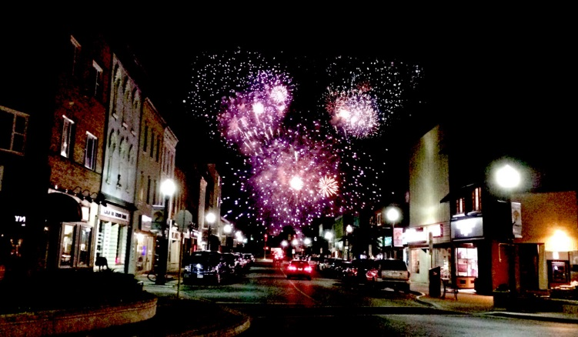
‘Mudcat Festival Fireworks’ Photo by Christine Edwicker
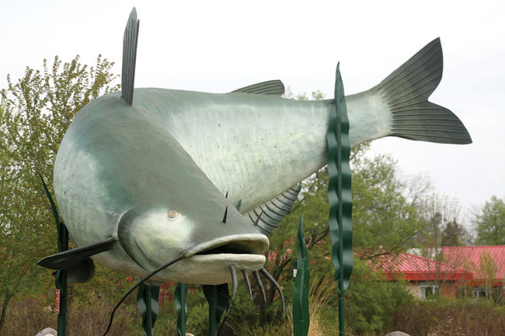
‘World’s Largest Mudcat’ Photo from Ontario’s Southwest

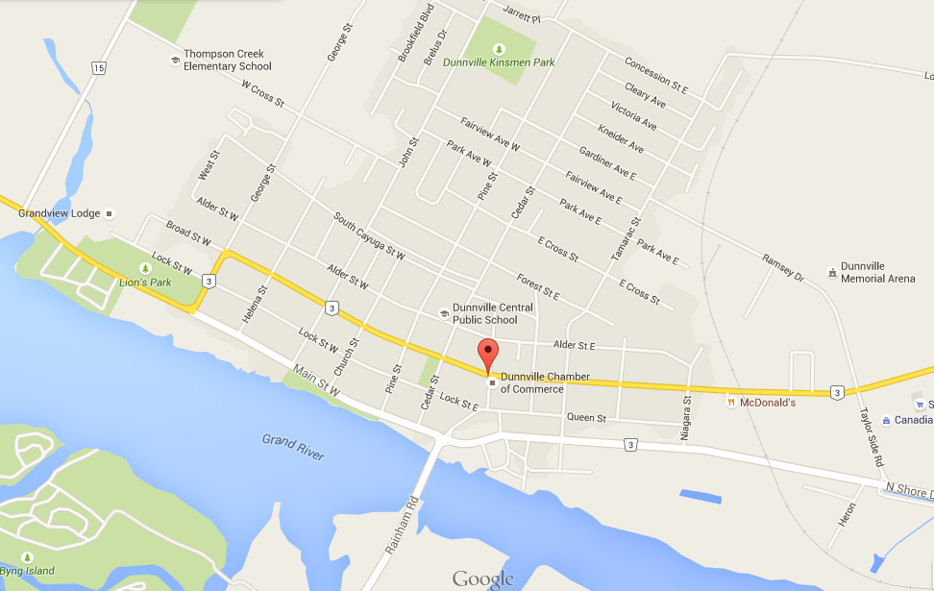
Town of Dunnville
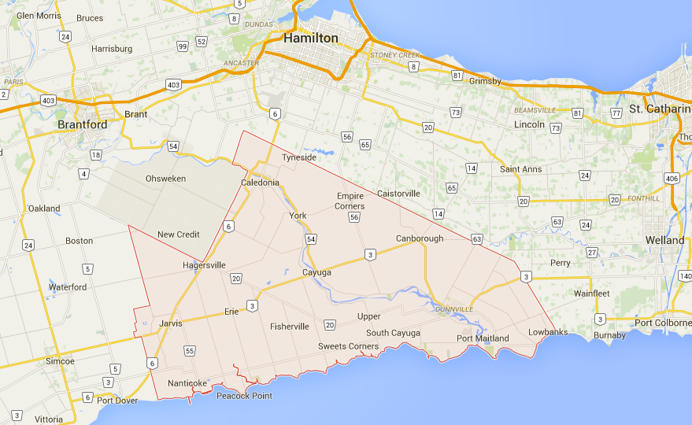
Haldimand County
Table of Contents
Emergency Services
Real Estate Companies
Lawyers
Insurance Companies
Banking and Investment Companies
Schools
Community Organizations
Service Clubs
Churches
Hospital
Dentists
Doctors
Veterinary & Pet Services
Optometrist
Pharmacies
Other Health Services
Motels
Bed & Breakfasts
Parks Recreation
Sports
Restaurants
Library
Museums
Annual Events
Attractions
Personal Care
Stores
Home Maintenance and Care

Emergency Services
Emergencies 9 1 1
*Haldimand War Memorial Hospital 400 Broad St. 905-774-7431
Haldimand County Fire Department 905-318-5932
O.P.P. 1-888-310-1122
Dunnville Non-Profit Housing Corporation 550 George Street 905-774-9111

Real Estate Companies
*Chase Realty 117 Queen Street E. 905-701-6001
*Coldwell Banker Brokerage 2-220 Broad Street E. 905-774-7624
RE/MAX Riverside Realty 310 Queen Street 905-774-4444
*Royal Lepage-Rob Shirton 115 Broad Street E. 905-775-7511
Royal Lepage State Realty 8 Stn Main Street 905-774-8144

Insurance Companies
*Co-operators 214 Broad Street E. 905-774-7576
Duliban Insurance Brokers 116 Queen Street 1-855-385-4226
*Erie Mutual 711 Main Street E. 905-774-8566
Fairlie Insurance 45 Regional Road 7. 905-774-8848
*Morison Insurance 6 Parkview Road, Hagersville 905-768-3384
(Formerly R.A. Bennet Insurance)
*Primerica Financial Service 304 Broad Street E. 905-701-7283
*Young’s Insurance Brokers 212 Maple Street 905-774-2622

Lawyers
Blue Heron Paralegal 223 Lock Street 289-377-9840
Szpeich, Ellis ,Skibikski & Shipton 115 Broad St. E. 905-774-7417
*Hedley & McLachlin 311 Broad St. E. 905-774-7688
Yanch & Hilliard 117 Queen St. 905-774-8025
Walker McQuatty 30 Pine Meadow Crt. 905-701-9529

Banking and Investment Companies
*Bank of Montreal 207 Broad Street E. 905-774-7551
Canadian Imperial Bank of Commerce 165 Lock Street E. 905-774-5434
*C.M.Sensabaugh Accounting 110 Elizabeth Crescent 905-774-6218
*Edward Jones- Paola Wortman Financial Advisor 905-808-4573
Financial Consulting Group 321 Broad Street E. 905-701-1792
*H&R Block 112 Lock Street E. 905-774-7015
IPC Investment Corporation – Marvin Ens 210 Chestnut Street 905-774-9266
*Pen Financial Credit Union 208 Broad Street E. 905-774-7559
*Primerica Financial Services 304 Broad Street E. 905-701-7283
*RBC Royal Bank 163 Queen Street 905-774-7491
Rigg Bookkeeping and Tax Service 115 Lock Street E. 905-774-5313
TD Bank Canada Trust 163 Lock Street E. 905-774-7491

Schools
Attercliffe Canadian Reformed Elementary 85785 Canborough Rd. 905-774-9009
Dunnville Christian School 37 Robinson Road 905-774-5142
Dunnville Secondary School 110 Helena Street 905-774-7401
Mapleview Public School 223 Fairview Ave W 905-774-6144
St. Michael’s Catholic Elementary 209 Alder St. W. 905-774-6052
Thompson Creek Public School 800 Cross Street W. 905-774-5460

Community Organizations

*Dunnville Agricultural Society 231 Chestnut Street 905-774-8199
Dunnville Boat Club 1 Mill Street 905-774-7039
Dunnville Business Improvement Association PO Box 53 905-774-6222
Dunnville Chamber of Commerce 231 Chestnut Street 905-774-3183
Dunnville Community Theatre 237 McLaughlin Rd. 905-774-7695
*Dunnville Heritage Association 317 Chestnut Street 905-701-8238
Dunnville Horticultural Society PO Box 274 416-566-9337
Dunnville Hunters and Anglers 237 McLaughlin Road 905-774-1138
*Dunnville Youth Impact Centre 215 Chestnut Street 905-774-6233
*Habitat for Humanity 103 Iverness Street 905-765-4408
*St. Leonard’s Community Services 208 Broad Street 905-774-7501

Service Clubs
*Dunnville Optimist Club 101 Main Street E. 905-774-7244
Kinsmen Club 102 Main Street W. 905-774-6940
Lioness Club PO Box 145 905-774-9348
Lions Club PO Box 186 905-774-5622
Rotary Club 233 Lock Street W. 905-774-4444
*Royal Canadian Legion Branch 142 305 Queen Street 905-774-5942

Churches
Bethany United R.R. 1 Dunnville 905-774-5238
Canadian Reform Church of Attercliffe 85950 Canborough Rd. 905-774-3237
Christian Reform 17 Robinson Rd. 905-774-7285
Dunnville Word of Faith 210 Forest Street W. 905-701-1214
Faith Lutheran 1308 Hwy 3 E. 905-774-3100
First Baptist 114 Broad Street W. 905-774-7225
Free Methodist 181 Cross Street E. 905-774-5111
Grace Reformed 514 George Street 905-774-6877
Grace United 301 Broad Street 905-774-4504
Jehovah’s Witness Kingdom Hall 612 George Street 905-774-3343
Jubilee Faith Centre 7869 Hwy 3 905-774-3050
Knox Presbyterian 223 Lock Street W. 905-774-5970
Maple Creek Community Church 110 Inman Road 905-774-6410
Port Maitland Christ Church 37 Lighthouse Drive No Phone
St. Michael’s Parish 204 Alder Street W. 905-774-6972
St. Paul’s Anglican Church 233 Lock Street W. 905-774-6005
South Cayuga Baptist 3475 Haldimand Rd. 20 905-774-5803
United Church of Canada 6182 Rainham Road 905-774-5150

Hospital
*Dunnville War Memorial Hospital 400 Broad St. W. 905-774-7431

Doctors
Dr. E Blake 410 Lock Street W. 905-701-6643
Dr. S. Kobah 400 Broad St. W. 905-774-7503
Haldimand Family Health Team 334 Broad Street 905-774-7541
- Dr. D Bernard
- Dr Ahmed Kamouna
- Dr. N. Reddy
- Dr. N. Desrochers
Dr. J. Howat Surgeon 400 Broad St. Room 201 905-774-7533

Dentists
Besma Dental and Aesthetic 237 Chestnut Street 289-738-7777
Dental Arts Building 303 Lock Street 905-774-7647
Dr. Dulmage
Dr. Telesnicky
Dentistry Dunnville
Sajid Syed 105 Lock Street E. 905-774-77608
Denture Clinic
Carmelo Cino DD 166 Queen St. 289-369-0292

Optometrist
*Dr. G Seddon & Associates 132 Queen Street 905-774-5417

Veterinary & Pet Services
*Dunnville Veterinary Clinic 110 Ramsey Drive 905-774-7642
Gentle Paws Pet Groomimg 220 Broad Street E. #4 905-701-3461
*Green Heron Veterinary Services 35 Lane Road. R.R.#1 905-701-2829
Pet Valu 220 Broad Street E. 905-701-0503
Photo Finish Dog Grooming 119 Broad Street E. 289-828-0299
*Ruffin’s Pet Centres 209 Queen Street 905-774-6373

Pharmacies
Rexall (Dell) Pharmacy 155 Lock Street E. 905-774-6222
*Grand River Pharmacy 334 Broad Street W. 905-229-2050
Hauser’s Home Health Pharmacy 140 Broad Street E. 905-774-7331

Other Health Services
*Alzheimer Society 111 Broad Street E. 905-229-2035
*Boost your Health and Wellness Centre 145 Lock Street E. 905-701-9518
*Dunnville Hospital and Healthcare 322 Broad Street W. 905-774-2529
Dunnville Physiotherapy 420 Lock Street W. 289-768-3687
Edgewater Gardens – Long Term Care 428 Broad Street W. 906-774-2503
Haldimand Family Health Clinic 334 Broad Street W. 905-774-7541
Haldimand Home Respiratory Services 160 Queen Street 905-701-4477
*Haldimand Pregnancy Care Centre 121 Alder Street W. 905-774-1228
Health and Social Services 117 Forest Street E. 905-318-5367
*KINnections Life Centre 121 Alder Street W. 905-741-4277
Meals on Wheels 657 Lock St 905-774-3005
*Senior Support Services 657 Lock Street W. 905-774-3005
Therapeutics 126 Queen Street 905-774-7774
*True Experience 201 Forest Street E. 905-774-6165
Motels
Country Inn Motel 8230 Hwy 3 W. 905-7747363
*Dunnville Suites 8232 Hwy 3 W. 289-518-0220
Riverview Motel 642 Main Street W. 905-774-5634
*Dunnvile Doslea Motel 1317 Hwy 3 E 289-518-0228
Bed & Breakfasts
* Dunnville Inn 809 George St. 289-735-2501
Evan’s Point Bed & Breakfast 2236 Lakeshore Road 905-774-5438
Hannah’s Irish Vacation Farmhouse 724 Port Maitland Drive 905-774-7028
*Hunter’s Heavenly Haven 671 Hines Rd. www.airbnb.ca
*Lalor Estate Inn 241 Broad Street W. 905-774-5438
Port Maitland Bed & Breakfast 8 Lighthouse Drive 905-774-6026
*The Reeve Bed and Breakfast 431 Queen Street 905-931-2941
Walnut Grove B&B 1193 Northshore Drive 905-774-5445
River Flatts B and B Port Maitland Book through Airbnb

Parks
Byng Island Conservation Area 4969 Haldimand Road 20 905-774-5755
Centennial Park 98 Robinson Road
Century Beach 2057 Lakeshore Road 905-774-3879
Central Park 206 Cedar Street
Gardiner Park 151 Gardiner Avenue E.
Garfield Disher Park 99 Bridge Street
James Allen Provincial Park Beach Myrnam Beach Road 905-774-6642
Kinsmen Park 985 John Street
Lions Park 640 Lock Street W. 905-774-7165
Rock Point Provincial Park 215 Niece Road 905-774-6642
Wingfield Park 290 Main Street W.

Recreation
Birchwood Acres Family Camping 301 Rattlesnake Road 905-774-5979
Blue Heron Trailer and Camping Grounds 2093 Lakeshore Road 905-774-3800
Bruce’s Landing 1019 Haldimand Road 17 905-774-4381
*Grand River Marina and Café 7336 Rainham Road 647-588-9032
Grand River RV Resort 1001 Haldimand Road 17, Cayuga 905-774-4257
Highland Trailer and RV Resort 1958 North Shore Drive 905-774-8082
*Knight’s Beach Resort 2190 Lakeshore Road 905-774-4566
*Maitland Shores RV Park 659 Port Maitland Road 905-774-8751
Oakwood Escape 7445 Hwy 3 W. 905-341-2004

Sports
Baldwin Cycle and Sport 1066Broad St. E. 905-701-3257
*Buckner’s Source for Sports 151 Queen Street 905-774-8871
Dunnville Golf and Country Club 150 Haldimand Road 17 905-774-3511
Dunnville Memorial Arena 275 Ramsey Drive 905-775-8480
Dunnville Minor Hockey 275 Ramsey Drive 905-774-2855
Fierce Fitness 205 Forest Street E. 289-518-0059
Freedom Oaks Golf Club 612 Sandy Bay Road 905-701-5120
Grand Paddle Sports 121 Port Maitland Road 289-887-64
*Grand River Marina and Café 7336 Rainham Road 647-588-9032
Lions Pool 640 Lock Street W. 905-774-7165
Long Beach Golf Club 13054 Lakeshore Road 289-821-6888
Premier Martial Arts 205 Cross St. E. 905-701-1117

Restaurants
A&W 213 Broad Street E. 905-774-7992
Bob’s Place 121 Lock Street E. 905-774-7463
Chip Witch 129 Tamarac St.S. 905-921-2217
*Country Chip Wagon 8232 Hwy 3 W. 905-701-0770
*Debb’s Cuisine on Queen 109 Queen Street 289-518-0322
*Doslea Diner and Motel 1317 Hwy #3 905-774-5600
Dunnville Deli 322 Broad Street E. 905
Flyer’s Café and Bakery 144 Queen Street 905-701-8527
Godfather’s Pizza 540 Main Street E. 905-701-0011
*Grand River Marina and Café 7336 Rainham Road 647-588-9032
Hyatt Restaurant 620 Main Street 905-774-7676
*Julia`s Bistro 217 Niagara Street E. 905-229-2929
KFC 311 Main Street E. 905-774-7091
Knowles Restaurant 174 Queen Street 905-774-6122
McDonalds 630 Broad Street E. 905-701-7309
The Minga 146 Queen Street 289-738-1198
Mings Garden 128 Lock St. E 905-229-9288
Pazzo’s Pizza 602 Main Street 905-701-9000
Pizza Hut 2-217 Broad Street E. 905-229-2222
Pothos Cafe’ 225 Queen St. 905-229-2535
Queen’s Hotel Restaurant 121 Main Street E. 905-774-6560
River’s Edge Restaurant 150 R.R. 17 905-774-4728
*Small Dimensions 209 Chestnut Street 289-518-0322
Squires Pizza 210 George Street 905-774-1488
Subventure 137 Broad Street E. 905-774-8033
Subway 211 George Street 905-701-9229
*Surf Shack at Knights Beach 2190 Lakeshore Road 905-774-4566

Tim Horton’s 936 Broad Street E. 905-774-9200
*Towne Cafe & Bake Shop 304 Broad St. E 905-701-8696
*The Big Scoop (ice cream truck) 137 Broad St. E. 905-220-7999

Library
Dunnville Public Library 317 Chestnut Street 905-774-4240
*Friends of the Dunnville Public Library 317 Chestnut Street 905-701-8238

Museums
Dunnville District Heritage Association 317 Chestnut Street 905-774-4240
*No. 6 RCAF Dunnville Museum 536 Port Maitland Road 905-701-7223

Annual Events
April Home and Garden Show Third weekend in April
*May Mudcat Marathon Mothers Day weekend
June Mudcat Festival Second weekend in June
Dunnville Town Wide Garage Sale
July Canada Day in the Park Celebration in Central Park July 1st
No. 6 RCAF Museum Annual Open House First weekend in July
August Dunnville Fair Third or Fourth Weekend
Dunnville Grand Cycling Tour Third or Fourth Weekend
September Terry Fox Run
November River Arts Festival
Remembrance Day at Dunnville Cenotaph
Dunnville Christmas House Tour End of November
December Santa Clause Parade and Light Up Night

Attractions
Bains Road Cider Co. 1019 Bains Road 905-979-5230
Byng Island Conservation Area 4969 R.R. 20 905-774-5755
Dunnville Community Theatre 101 Main Street E. 905-774-9491
Evans Point Evans Point Lane 1-800-863-9607
*Grand River Marina and Café 7336 Rainham Road 647-588-9032
Knight’s Beach 2190 Lakeshore Road 905-774-4566
Long Beach 2211 Hickey Road
Mark II Harvard Aircraft Display 317 Chestnut Street 905-774-4240
Mudcat Bowling Alley 1123 Broad Street E. 905-774-7671
Muddy, The World’s Largest Mudcat Robinson Road
Port Maitland Lighthouse and Pier Port Maitland Road
Port Maitland Lock and Cairn Canal Bank Road

Personal Care
Artisan Nails and Spa 220 Broad Street E. 905-701-7777
Dark Dezire Tanning Salon 311 Queen Street 905-774-6918
Durant’s Unisex Hair Salon 145 Queen Street 905-774-5657
*Good Looks Hair Design 235 Chestnut Street 905-774-4967
*Nails & Lashes by Ky Victoria Avenue 905-701-3032
Tips 2 Toes Nail Salon 117 Lock Street E. 905-701-1288

Stores
*Canadian Tire 1002 Broad Street E. 905-774-7545
Dollarama 180 Queen Street 905-701-5852
Food Basics 107 Bridge Street 905-774-6852
*Giant Tiger 231 Queen Street 905-774-5551
*Grand Erie Home Hardware Building Centre 1051 Broad Street E. 905-774-6115

*Laverty’s Home Furnishings 1150 Broad Street E. 905-774-6342
*Mattress Man 138 Queen Street 905-701-0660
Sobeys 1012 Broad Street E. 905-701-6662
*Sweet Retro-Spect 170 Queen Street 905-774-8725

Home Maintenance and Care
*Cooper’s Flooring 311 Queen Street 905-774-5383
*Enviro Clean 905-317-8047
*Hines Electric 126 Tamarac Street 905-774-5954
*Ideal Roofing Plus 397 Marshall Road 289-456-5135
*Jeff’s Outdoor 3552 Regional Road 56 905-765-4200
*Muis Windows & Doors Inc 8393 Highway 3 West 905-774-3175
*Norm’s Water Haulage 671 Hines Road 905-774-8146
*WD Moody Concrete 2583 North Shore Drive 905-774-4898

